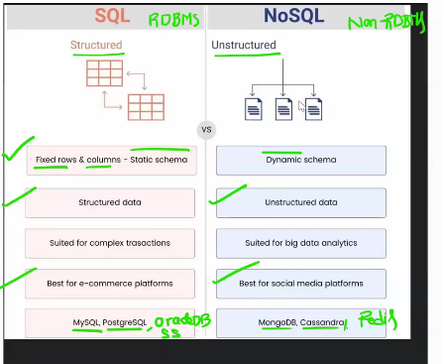

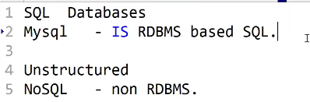

6 DB - is a structure collection data

## four sub languages :

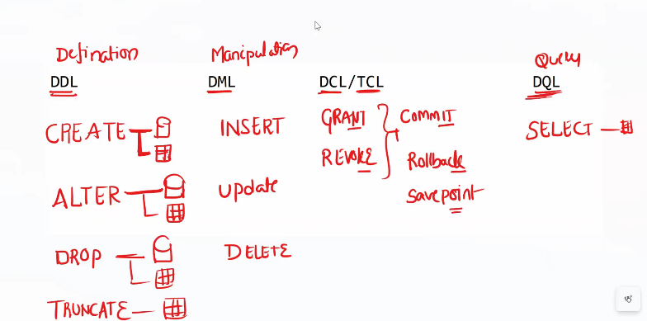

CREATE READ UPDATE DELETE

Class-1:

Mysql -uroot -proot

List 0F

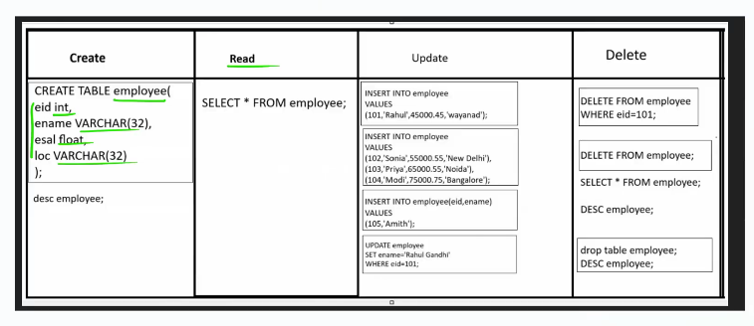



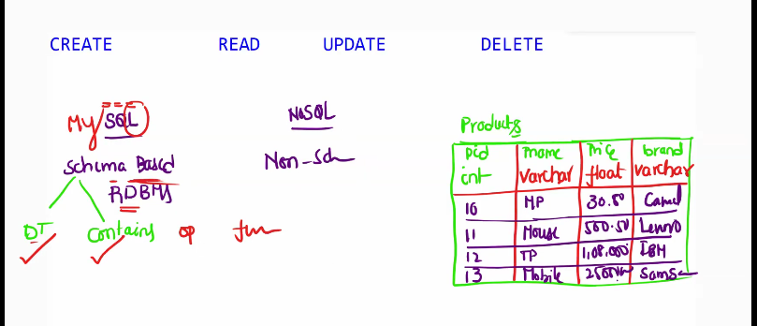

**MySQL Constraints (Rules on data )**

Not Null – null values not allowed but duplicate value allowed

Unique – duplicate not allowed but null allowed

Default

Check – rules(condition like - age > 18)

Primary – not null + unique

Foreign key

Index –

Create table employees();

Create table employees(

eid int UNIQUE,

ename varchar(32) NOT NULL,

esal float NOT NULL,

loc varchar(32) DEFAULT ‘bangalore’

);

Create table employees(

eid int unique,

ename varchar(32) not null,

esal float not null,

age int check(age>=18),

loc varchar(32) default ‘banglore’

);

## What is primary key

* Not null + unique
* Table has only one primary key
* But multiple foreign key

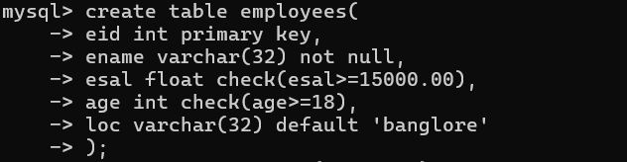

## Foreign key ??

Customers orders

1 customer can place multiple orders

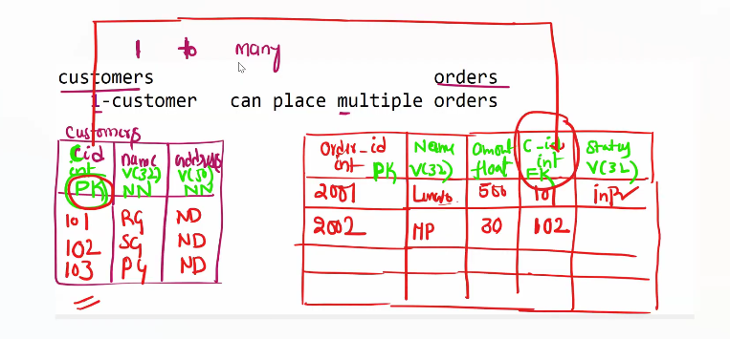

## Customers table :

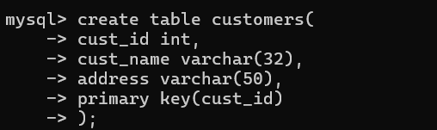

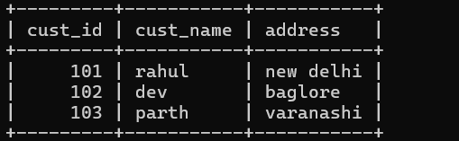

## Order table :

